Selling C of E Primary School
Handwriting and Presentation Policy
Draft

Showing compassion, learning together, flourishing as one
at
Selling CE Primary School

Here at Selling Church of England Primary School, we are very proud of our pupil’s handwriting and take particular care in developing a well-formed handwriting style, with a focus on print in EYFS and into Year 1, following the Little Wandle mantras for letter formation. This is then developed into pre-cursive and then cursive as children progress.
Handwriting is a basic skill that influences the quality of work throughout the curriculum. At the end of Key Stage 2 all pupils should have the ability to produce fluent, legible and, eventually, speedy joined-up handwriting, and to understand the different forms of handwriting used for different purposes.
We aim to make handwriting an automatic process that does not interfere with creative and mental thinking.

Rationale
Our policy is in place to ensure that the teaching of handwriting is a developmentally appropriate progression from mark making to formal handwriting. Handwriting is an essential tool that facilitates children to express themselves effectively in all areas of their bespoke curriculum. Therefore, we aim to ensure all children develop a fluent, legible and cursive script in their writing, to enable them to become confident, expressive and effective writers.

Aims
- To ensure handwriting is taught in line with developmentally appropriate milestones.
- To enable learners the opportunity to develop a script that is legible and fluent.
- To raise the standard in handwriting and cursive script across the school.

School aims
- We aim for our pupils to develop a neat, legible, speedy handwriting style using continuous cursive letters that leads to producing letters and words automatically in independent writing. By the end of Year 6 pupils will understand the importance of neat presentation and the need for different letterforms (cursive, printed or capital letters) to help communicate meaning clearly.
Method
- Our teachers are encouraged to use neat, joined-up cursive writing for all handwriting tasks including report writing (when not word-processed), marking and comments. Consistency throughout the school Pupils should experience coherence and continuity in the learning and teaching of handwriting across all school years and be encouraged to take pride in the presentation of their work. The correct use of capital letters is seen as important from the start of writing, therefore improper use of capitals letters in the middle of words and sentences as well as missing capital letters for proper nouns is picked up on throughout the school. Our aim is to help pupils enjoy learning and developing their handwriting with a sense of achievement and pride.
Handwriting frequency
- Handwriting is a cross-curriculum task and will be taken into consideration during all lessons. Formal teaching of handwriting is to be carried out regularly and systematically to ensure Key Stage targets are met.

FOUNDATION: For our youngest pupils we aim for one to taught session per week and one independent session to consolidate the teaching. This is introduced and reinforced during daily Phonics teaching as well through homework. We focus on;
- Movements to enhance gross motor skills such as air-writing, pattern making, dancing.
- Exercises to develop fine motor skills such as making marks on paper, whiteboards, sand trays, tablets.
- Letter learning to familiarise letter shapes, formation (with Little Wandle mantras) and vocabulary.

Left-Handed Pupils
- Left-handed pupils should sit to the left of a right-handed child so that they are not competing for space.
- Pencils should not be held too close to the point as this can interrupt pupils’ line of vision.
- Extra practice with left-to-right exercises may be necessary before pupils write left-to-right automatically.
Inclusion
- Children whose handwriting is limited by problems with fine motor skills, including left-handed children, and children with special educational needs, will be given additional support, such as angling the paper. Additional resources may also be used (i.e. a writing slant).
Pens and Pencils
- Children are encouraged to start handwriting using a soft pencil. When fine motor skills have been established a handwriting pen can be used.
Equality Statement
- Equality Impact Assessment Under the Equality Act 2010 we have a duty not to discriminate against people on the basis of their age, disability, gender, gender identity, pregnancy or maternity, race, religion or belief and sexual orientation. This policy has been equality impact assessed and we believe that it is in line with the Equality Act 2010 as it is fair, it does not prioritise or disadvantage any pupil and it helps to promote equality at this school.
There are specific targets for each year group.

In Year 1, pupils should be taught to:
- Sit correctly at the table, holding a pencil comfortably and correctly.
- Begin to form lower case letters in the correct direction, starting and finishing in the right place.
- Form capital letters.
- Form the digits 0 to 9.
- Understand which letters belong to which handwriting ‘family’ (a group of letters that are formed in the same way).
- Follow the Little Wandle programme for introducing writing
In Year 2, pupils are expected to:
- Form lower case letters of the correct size, relative to one another.
- Start using some of the diagonal and horizontal strokes needed to join letters, and understand which letters are best left unjoined.
- Write capital letters and digits of the correct size, orientation and relationship to one another.
- Use spacing between words that is appropriate for the size of the letters.

In Years 3 and 4, children should:
- Continue to develop their joined-up handwriting.
- Increase the legibility, consistency and quality of their handwriting – for example, ensuring that downstrokes of letters are straight and parallel, not sloping.

In Years 5 and 6, children are taught to:
- Write with increasing legibility, fluency and speed.
- Choose which shape of a letter to use, and decide whether or not to join specific letters.
- Choose the writing implement that is best suited for a task.

Special Educational Needs consideration-
It is understood that some pupils will find it beneficial to stand when writing and can access standing desks/working stations. Some pupils may need more space than their peers and use a full desk space. Some pupils may need writing aids. Each pupil’s needs will be considered and supported on each individual basis.
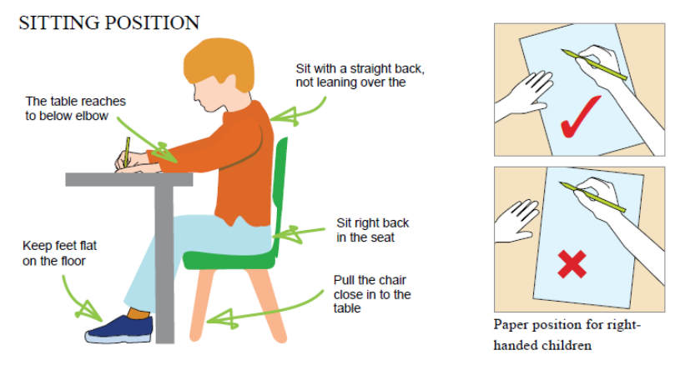

Teaching and learning - preparation
The teaching and learning of handwriting, is a physical skill and progression needs to be physically and developmentally appropriate. At Selling School we aim to provide children with the opportunity to develop handwriting skills progressively through the curriculum and the ages and stages of individual children.
We promote a learning environment which is supportive to the development of successful writing by:
Classroom environment: ensuring tables and chairs are at an appropriate height for children in each classroom, that there is good and natural light, adequate space for individuals, the atmosphere is calm and that a range of good quality writing materials and equipment are readily available. In addition, displays and resources used in each classroom should reflect the style of handwriting that is expected of the children in that class.
Sitting position: Pupils should be sat right back in their chairs with their kneed at 90 degrees and feet planted on the floor. Children’s chairs should be tucked in but their torsos should not be touching the table so there is space to bend.
Paper position: Children should write with their forearm resting on their paper to anchor it, children should move the paper up the table with their non-writing hand as they write, allowing their wrist to stay below the writing line. Tilting the paper makes writing more comfortable and allows children to see what they are writing. Left handed writers should tilt the paper down and right handed writers should tilt the paper up. This should be modelled to children as and when needed.

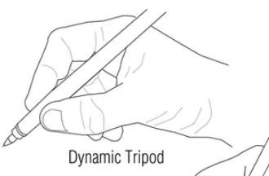
Pencil/Pen grip: When they are developmentally ready to write, children should be taught the dynamic tripod grip.

Pupils should be able to see the nib of their writing implement and their wrist should be below the writing line. The child should not press too hard and the writing shouldn’t hurt.
Modelling: All adults working with a class will model the handwriting that is expected of the class whether that be when modelling writing on a flip chart/IWB, or when giving written feedback in books. For example, in EYFS adults will use print form. In year 2 when teaching entry and exit strokes, adults will model this. In KS2, where the expectation is that all children will be using the cursive style, this will be modelled.

Teaching and Learning - Progression
EYFS
In the Early years classroom at Selling School, we ensure children have ample opportunity to engage in fine and gross motor skills activities in practical and appropriate ways and to ensure children have access to a multi-sensory approach to develop good writing habits.
Gross motor skills are developed through a broad range of activities, supporting children to explore the control of large movements and direction using the whole body. Activities such as PE, climbing and moving in a variety of ways and on a range of surfaces (such as tarmac, grass, sand, pebbles, woodland), and write dance activities encourage children to develop the movements they need to support the development of handwriting.
Fine motor development is encouraged through a range of activities that involve developing control through small scale movements such as using tweezers, pegboards, weaving, chopping and peeling, clay, playdough, finger-paints, finger rhymes and dough disco. Children are also offered a range of practical and tactile activities to practise the movement and formation of letter shapes.
Year one
In year one, many of the physical and practical activities that the children are accustomed to within the EYFS are continued to ensure children maintain progress at a developmentally appropriate rate. Children in year one will revisit letter formation. This ensures the opportunity to further refine the hand control when forming letters and letter heights, ascenders, descenders are also explored. Children should be taught to write letters that are uniform in size. Children are also taught the formation of capital letters and digits 0-9. Further, children should be taught to ensure that all letters and digits sit on the line.

Year two
In year two, increasing attention is given to the learning of letter heights, ascenders, descenders and the placement of capital letters. Once children are confident with their letter formation they should be taught to add a “flick” (exit stroke) for each letter followed by the (entry stroke) “lead in”. By the end of year 2 some pupils may be ready to begin to naturally join the letters in their writing and further skills such as the joining of letters with diagonal joins, horizontal joins and ascender joins will begin to be taught.
Year three
In year three, cursive handwriting should begin to become the norm for most children. In this year group children will build on their knowledge and skill of handwriting joins including diagonal, horizontal and ascender joins. They will begin to develop handwriting that is increasingly legible and consistent and make good choices about which joins to use and when to leave some letters un-joined.
Year four
Continuing from year 3, children in year four will continue to increase legibility of their handwriting using correct joins and begin to understand which letters are best left un-joined when adjacent to each other. Children in year four will begin to develop consistency of letter and word spacing, ensuring that the ascenders and descenders of letters do not touch. Children in year four will be developing speed in their handwriting, with the aim of increasing the fluency with which pupils are able to write down what they want to say.
Year five
Year five children will continue to practise and develop the speed of their handwriting. They will learn to choose which writing implement suits a given task and begin to make choices about joined or un-joined handwriting for a variety of tasks – for example to write down an email address, fill in a form, label a diagram or record data.
Year six
In year six, most children will have developed a legible, fluent and cursive script. Children will continue to learn to maintain this when writing at efficient speed. They will be confident to make choices about letter joins or when to use un-joined writing for specific formats.
Timetabling of handwriting
At Selling School, in EYFS, KS1 and Year 3, handwriting will be taught daily as a discrete lesson. From year 4 upwards, handwriting will be taught depending on the needs of the class and according to the professional judgement of the teacher. Children will be taught the progressive skills outlined above and handwriting lessons may incorporate year group spelling lists, to ensure fluency and consistency when spelling common exception words. Handwriting will be carefully monitored by teachers in all opportunities for writing across the bespoke curriculum and by the English lead during book scrutinies.

Handwriting resources
Handwriting tools:
Throughout their time in school, children use a range of tools for different purposes and styles of handwriting including:
• A wide range of tools and media for mark-making in the EYFS.
• A selection of pencils which support effective grip in KS1 &2
• Whiteboard pens throughout the school.
• Art supplies including coloured pens and pencils for posters, displays and artwork.
• Handwriting pens once a pen license has been awarded.

Books and paper:

Children need appropriately spaced lines in writing books to match developmental need, ensuring that letters are not squashed and to allow sufficient space for letter alignment. As children’s motor skills increase, their letter formation and joining becomes more accurate and in turn, the width between line spaces naturally decreases. The line spaces in books for each year group is in line with progression points, however this can be flexible at all stages depending on the needs of the individual.

Line spacing guidelines

Year R | Half lined pages – 15mm spacing between lines
Year 1 | Fully lined pages with 15mm spacing.
Year 2 | Fully lined pages – 15mm spacing moving on to 12mm spacing.
Year 3 | 12mm spacing moving to 8mm
Year 4 | 8mm spacing
Year 5 | 8mm spacing
Year 6 | 8mm spacing

When modelling handwriting, teachers and TA’s should use the same sized lines as above. Specific handwriting paper with guidelines on should not generally be needed, however, it may be useful as an intervention for older pupils who struggle with sizing of letters.

Pen licences
Pen licences are an important goal where children work towards graduating from writing in pencil to pen. From year 3 children have the opportunity to earn a gold star sticker in their books for legible, cursive, handwriting showing that choices about how to join letters are mostly correct. As the children progress and show consistency in all these areas and across all subjects, they will earn more stars and once they have achieved 5 will be given a pen to write with in class.

Agreed Language
Staff use consistent language to describe handwriting, including: Letter families, lower case, upper case, capital letters, ascenders, descenders, x-height letters, exit flicks, joining stroke. We use technical language to support children with difficulties rather than the derogatory ‘messy’, ‘untidy’.

Inclusion, equal opportunity and the bespoke curriculum for every child
At Selling School we are committed to ensuring the learning needs of every child are met through a bespoke curriculum. Through the use of planned and differentiated activities, we ensure a variety of approaches to support the appropriate next steps in handwriting learning for each and every individual. Where necessary, and often in liaison with the SENCO, we use additional resources such as writing slopes, adapted writing tools and grips to support the development of each individual. Further, intervention programmes such as Clever Fingers, Write Dance and *** may be used for some children.

The left handed writer
Left handed writers are given guidance to support the process of writing in the following ways;
- They will be sat on the left of right handed children so their arms do not clash
- They will be taught how to tilt their paper/book to ensure they can see what they have written
- They are encouraged to foster a pencil/pen grip that is slightly higher than a right handed writer, to ensure the reduction of smudging their writing

Presentation
At Selling School we have high expectations of presentation. We expect children to adhere to our high expectations and have pride in their work. These high expectations will be evident across the curriculum and visible in all of the children’s work.

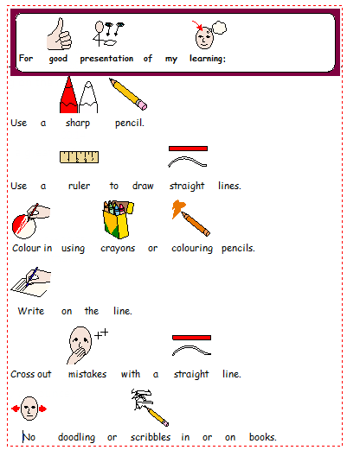
In KS1 we expect:

In KS2 this develops to:

- Write the long date for all pieces of work except for maths when the short date is used

- Date and title is underlined using a ruler

- Margins are drawn using a sharp pencil and ruler

- Middle margins are used in maths books

- Mistakes are crossed out using a straight line drawn with a ruler

- Write using a sharp pencil unless you have a pen licence: pens must use blue ink

- Drawings should be in pencil; colour in using pencils or crayons. Felt tips may be used for some pieces with special permission from your class teacher

- Any paper stuck into books should be stuck in straight and be trimmed to fit the page

- No doodling in or on any book

All adults reinforce these standards in their modelling when writing on the board or in books; by asking children to improve upon presentation that is not of the expected standard and by celebrating work that achieves and models the standard set out.

Appendix 2 – Order of Letter Joins
There are 2 types of join:
Diagonal joins – joins from the base line. Letters which come before diagonal joins: a, c, d, e, h, I, k, l, m, n, t, u.
Horizontal joins – joins from the top of letter or a cross bar. Letters which come before horizontal joins: o, v, w
Order of joins to be taught:
Diagonal joins to letters without ascenders (join from the base line)
in im um an un ae ce ee ie de he ke le te me ne se ue ar si sn su sw ay ag ap ip ge gi gu ji ju je ye yi fu fe fi
Diagonal joins to ascenders (join from the base line)
lk nt nk sk sl st ub ck el il ch eh ll lt sh th at et it nt ut ab ul af ef uf if ff fl
Diagonal joins to anti-clockwise letters (join from the base line)
sa sc so sq as ds es is ks ls ms ts us ss ag nd ta la ya ga go fa fo ja jo
Horizontal joins to letters without ascenders (join from the top of the letter or a cross bar)
wi we wu oe ve vi vu re ri ru oy og op
Horizontal joins to ascenders (join from the top of the letter or a cross bar)
wh rt rk rl ob ok ot ol of
Horizontal joins to anti-clockwise letters (join from the top of the letter or a cross bar)
og oo oa oc va vo vs wa wo ra ro rs



