Selling CE Primary School
Nut-Aware Policy
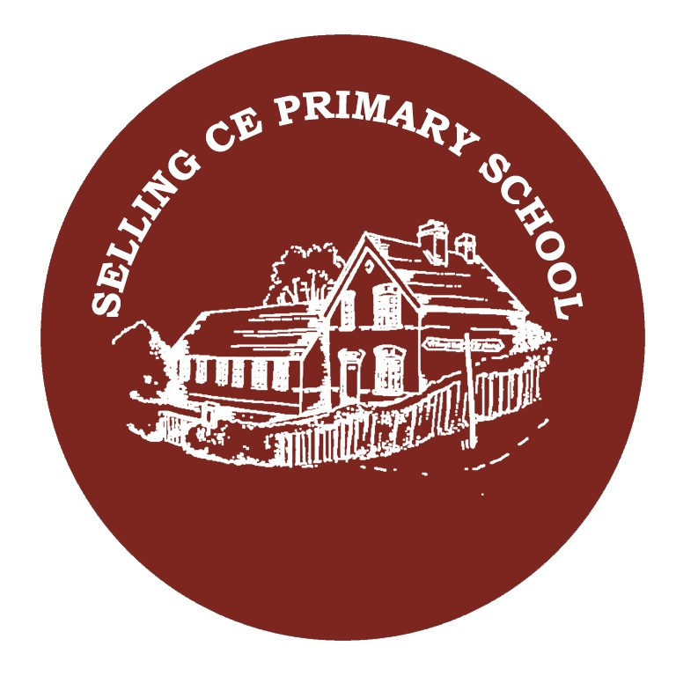

Revised: September 2025 Date of next review: September 2026
Authorised by: Mrs L King

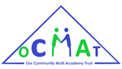
Showing compassion, learning together, flourishing as one at
Selling CE Primary School

Introduction

Although we recognise that this cannot be guaranteed, Selling CE Primary School aims to be a Nut-Aware school. This policy serves to set out all measures to reduce the risk to those children and adults who may suffer an anaphylactic reaction if exposed to nuts to which they are sensitive. The school aims to protect children who have allergies to nuts yet also help them, as they grow up, to take responsibility as to what foods they can eat and to be aware of where they may be put at risk. We do not allow nuts or nut products in school lunch boxes.

Principles

The underlying principles of this policy include:

The establishment of effective risk management practices to minimise the student, staff, parent and visitor exposure to known trigger foods. Staff training and education to ensure effective emergency response to any allergic reaction situation.

This policy applies to all members of the school community:

• School staff, including supply staff and students

• Parents/carers

• Volunteers

An allergic reaction to nuts is the most common high-risk allergy, and as such demands more rigorous controls throughout the policy.

Definitions

Allergy - A condition in which the body has an exaggerated response to a substance (e.g. food and drug) also known as hypersensitivity.

Allergen - A normally harmless substance that triggers an allergic reaction in the immune system of a susceptible person.

Anaphylaxis - Anaphylaxis, or anaphylactic shock, is a sudden, severe and potentially life-threatening allergic reaction to food, stings, bites, or medicines.

Epipen - Brand name for syringe style device containing the drug Adrenalin, which is ready for immediate inter-muscular administration.

Minimized Risk Environment- An environment where risk management practices (e.g. Risk assessment forms) have minimised the risk of (allergen) exposure.

Health Care Plan- A detailed document outlining an individual pupils condition treatment, and action plan for administration and location of their Epipen.

Legal framework

The Human Medicines Regulations (2012)

section 100 of the Children and Families Act 2014

Managing Medicines in Schools and Early Years Settings (DfES 2005)

supporting pupils at school with medical conditions

Food Information Regulations 2014

advice for schools, colleges and nurseries

Resources
www.gov.uk - Allergy Guidance for Schools
www.allergyuk.org - Epipen plans

Our “Nut-Aware Policy” means that the following items should not be brought into school:

● Packs of nuts

● Peanut butter sandwiches

● Fruit and cereal bars that contain nuts

● Chocolate bars or sweets that contain nuts

● Sesame seed rolls (children allergic to nuts may also have a severe reaction to sesame)

● Cakes made with nuts

We have a policy to not use nuts in any of our food prepared on site at our school. Our suppliers provide us with nut-free products. However, we cannot guarantee freedom from nut traces.

We also cannot give out any sweets brought in from home to be given out as birthday treats.

Procedures and Responsibilities for Allergy Management
General
- Parents and staff will work together to develop individual Health Care Plans.
- The school will establish and maintain systems for effectively communicating a child’s healthcare plans to all relevant staff.
- Staff will be trained in anaphylaxis management, including awareness of triggers and first aid procedures to be followed in the event of an emergency.
- Children will be given age appropriate education about severe food allergies.

Medical Information
- Parents of children with known allergies will be asked to update their child’s information via the medical form at the start of each academic year.
- Parents must immediately report to the school any change in their child’s medical condition during the year.
- For children with known allergies, parents/cares must provide written advice from a doctor (GP), which explains their child’s condition, and defines the allergy triggers and any required medication.
- The SENCo will ensure that a Health Care Plan is established and updated for each child with a known allergy.
- All Teachers and Teaching Assistants, Wrap Around Staff and other key staff must ensure that they are aware of any children with allergies in the classes that they have contact with and must review and familiarise themselves with the medical information for these children.
- If parents give permission, Action Plans with a recent photograph for any children with allergies will be posted in relevant rooms.
- When children with known allergies are participating in school excursions or other activities away from the school site, the risk assessments must include this information and a plan for minimising the risk of exposure to allergens and treating any adverse reaction that may occur.
- Children with known allergies may wear a medic-alert bracelet if they choose to.

General

It is the parents’ responsibility to provide to the school in writing ongoing accurate

and current medical information about their child.

For a child with a known allergy or a newly-diagnosed allergy, parents must send a letter to the school confirming the allergy and giving the following information:

The allergen (the substance the child is allergic to).

The nature of the allergic reaction (e.g. rash, breathing problems to anaphylactic shock).

What to action must be taken if the child has an allergic reaction, including any medication, dosages and how it is to be administered.

Any control measures that can be put in place to prevent an allergic reaction occurring.

It is the parents’ responsibility to ensure that the contents of any snacks and lunches that their child brings in to school are safe for the child to consume. Selling CE Primary School has a strict no sharing of food and drink policy. Parents should liaise with staff about the suitability of ingredients for any food-related activities (e.g. cooking) and provide a list of all food products and food derivatives that their child is known to be allergic to. All parents/carers, regardless of whether or not their child has a known allergy, must ensure that any snacks and lunches that their child brings in to school are free of peanuts and other nuts. The school will ensure that parents/carers are regularly

reminded of this and will monitor the contents of lunchboxes and snacks.

Epipens

If a child has an allergy requiring an Epipen, or the risk assessment deems it necessary, a Health Care plan must be completed and signed by the parents.

It is the parent’s/carer’s responsibility to ensure that 2 Epipens are in school and in date. The Epipens must be clearly labelled and in a suitable container.

Any child with an allergy requiring an Epipen will not be allowed to attend school without an in-date Epipen.

The Epipens will be located securely in two agreed locations in a box clearly labelled with the child’s name and photograph and with a copy of the child’s Care Plan.

Parents/carers must ensure that the school has up to date emergency contact information.

Staff Responsibilities

It is the responsibility of every staff member to familiarise themselves with this policy and to adhere to the school’s health & safety regulations regarding food and drink.

Every Teacher, Supply Teacher, Teaching Assistant, wrap around staff and anyone else who has regular contact with children must ensure that they are aware of any children with allergies in the classes or groups that they work with. This information is available in each class, staff room, school office, school kitchen and SENCO’s office.

All staff are to encourage all children to wash their hands before and after eating.

Staff should monitor any snacks and packed lunches that children bring in from home to ensure that they do not contain peanuts, nuts or other known allergens. (We cannot, however, guarantee that foods do not contain traces of nuts.)

Children should not be permitted to share any food or drinks that they have brought from home under any circumstances.

After eating, all tables must be cleaned with an approved solution.

Staff will be offered Epipen training and all staff will be made aware of the location of Epipens for children who need them.

Emergency medication should be easily accessible at all times, especially at times of high risk such as school trips and off-site visits.

Staff should consult with parents/carers in advance about the suitability of any planned food-related activities (e.g. snacks, food sample sessions, cooking).

New pupils with allergies

If a child’s Enrolment Form states that they have an allergy, a Health Care Plan must be in place before the child starts attending sessions. A risk assessment should be carried out and any actions identified must be put in place. This assessment should be stored with the child’s Health Care Plan.

Diagnosis of an allergy for an existing pupil

If a child already attending Selling CE Primary School is diagnosed with a new allergy, a team meeting will be set up as soon as possible to update all relevant staff of the details of the child’s allergy and treatment.

The SENCO will ensure that all staff who come into contact with the child will be made aware of what treatment/medication is required and where any medication is stored.

In the event of a child suffering an allergic reaction:

Parents/carers will be contacted immediately.

If medication has been prescribed, this will be administered as per training.

If the child becomes distressed or their symptoms become more serious an ambulance will be called.

Staff will endeavour to keep calm, make the child feel comfortable and give the child space.

If an ambulance is called and arrives before the parent/carer has arrived, a member of Staff will accompany the child to hospital.

